**BINUS UNIVERSITY**

**BINUS INTERNATIONAL**



**Assignment Cover Letter**

**(Group Work****)**

|  |  |  |  |  |  |  |  |  |
| --- | --- | --- | --- | --- | --- | --- | --- | --- |
|  | | | | |  | |  | |
| **Student Information: Surname** | | | | | **Given Names**  **Edgar**  **Arden**  **Steven** | | **Student ID Number**  **2101699666**  **2101**  **2101704602** | |
| **1.**    **2.**  **3.** | | **Tandiawan**  **Djaja**  **Lee Himawan** |  | |
|  |  |
| **Course Code** | **: COMP6505** |  |  | | **Course Name** | | **: Computer Graphics** | |
| **Class** | **: L4BC** |  |  | | **Name of Lecturer(s)** | | **:** **1.Raymondus Raymond Kosala, Ph.D.** | |
|  |  |  |  | |  | |  | |
| **Major** | **: CS** |  |  | |  | |  | |
| **Title of Assignment**  (if any) | : **Racing Game Simulation** | |  | **Type of Assignment** | | : **Final Project** | |  | |
| **Submission Pattern** |  |  |  | |  | |  | |
| **Due Date** | **: 02-07/2019** |  |  | | **Submission Date** | | **: 02-07/2019** | |

The assignment should meet the below requirements.

1. Assignment (hard copy) is required to be submitted on clean paper, and (soft copy) as per lecturer’s instructions.
2. Soft copy assignment also requires the signed (hardcopy) submission of this form, which automatically validates the softcopy submission.
3. The above information is complete and legible.
4. Compiled pages are firmly stapled.
5. Assignment has been copied (soft copy and hard copy) for each student ahead of the submission.

# **Plagiarism/Cheating**

BiNus International seriously regards all forms of plagiarism, cheating and collusion as academic offenses which may result in severe penalties, including loss/drop of marks, course/class discontinuity and other possible penalties executed by the university. Please refer to the related course syllabus for further information.

# **Declaration of Originality**

By signing this assignment, I understand, accept and consent to BiNus International terms and policy on plagiarism. Herewith I declare that the work contained in this assignment is my own work and has not been submitted for the use of assessment in another course or class, except where this has been notified and accepted in advance.

Name of Student: (Signature of Student)

1. Edgar Tandiawan
2. Arden Djaja
3. Steven Lee Himawan

Final Project Report

In this report, we will explain about our group project that is racing game simulation, in this game you can control your own car and race against one another with the button that have been provided by the game maker. We want this game for simple and easy to play so people don’t get confused which button should they press.

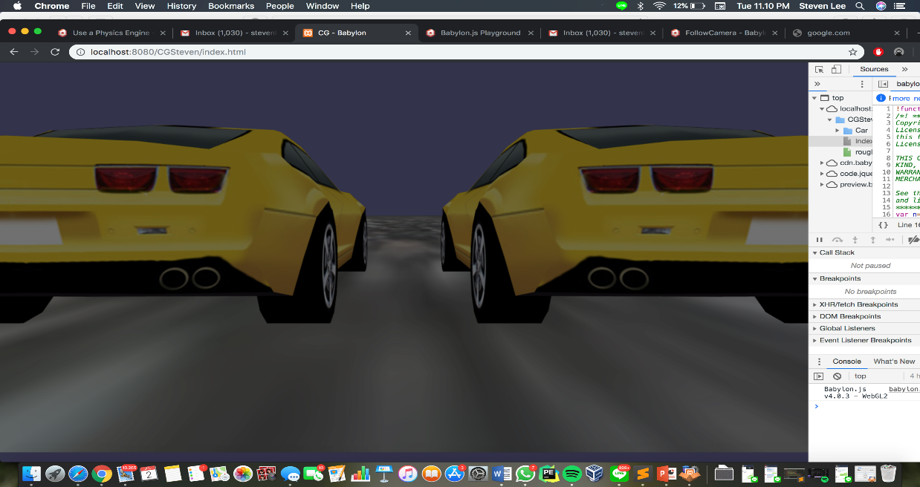

**Controls:**

**To move use W A I K**

In the picture below people can see the gameplay and what will if you start the game and race.

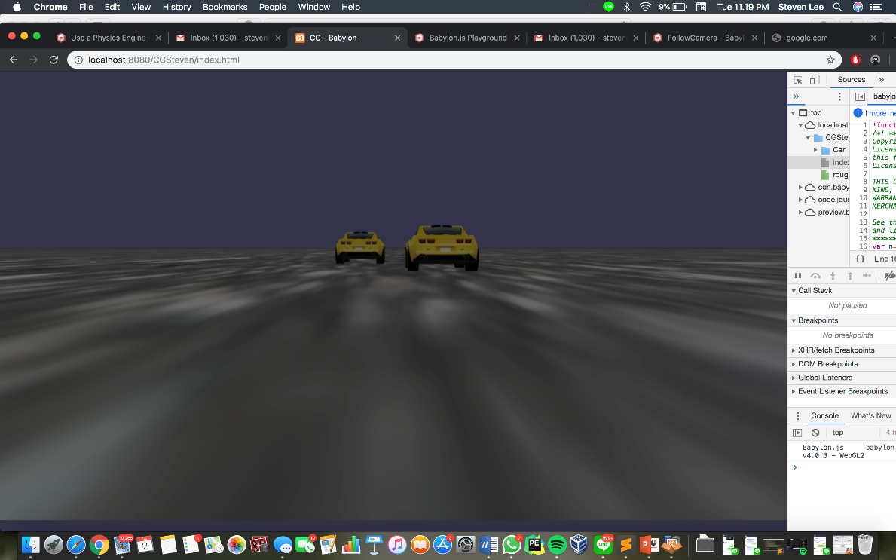

The purpose of choosing this game is because it seems fun and enjoyable for people and also for our final project. We hope that maybe it seems lack as overall but we would like to people to enjoy our game.